**727721EUIT158**

**SRIKANTH S**

**DAY 7**

**TASK 1:**

package com.demo.demo;

import org.openqa.selenium.WebDriver;

import org.openqa.selenium.chrome.ChromeDriver;

import org.openqa.selenium.chrome.ChromeOptions;

import org.testng.Assert;

import org.testng.annotations.Test;

import io.github.bonigarcia.wdm.WebDriverManager;

public class Day7_01 {

@Test

public void f() {

WebDriverManager.chromedriver().setup();

ChromeOptions co=new ChromeOptions();

co.addArguments("--remote-allow-origins=*");

WebDriver driver=new ChromeDriver(co);

driver.get("https://demo.wpeverest.com/user-registration/guest-registration-form/");

driver.manage().window().maximize();

String actual=driver.getTitle();

String expected="Guest Registration Form – User Registration";

Assert.assertEquals(actual,expected);

}

}

**OUTPUT:**

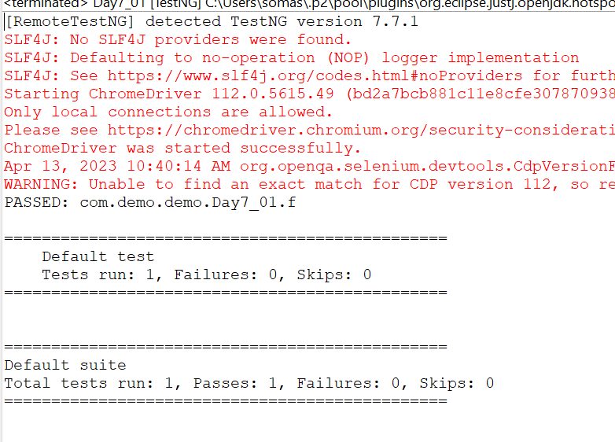

**TASK 2:**

package com.demo.demo;

import org.testng.Assert;

import org.testng.annotations.Test;

public class Calculator {

@Test

public void add() {

int num1=10;

int num2=20;

int result=num1+num2;

Assert.assertEquals(result,30);

}

@Test

public void sub() {

int num1=20;

int num2=10;

int result=num1-num2;

Assert.assertEquals(result,10);

}

@Test

public void mul() {

int num1=10;

int num2=20;

int result=num1*num2;

Assert.assertEquals(result,200);

}

@Test

public void div() {

int num1=20;

int num2=5;

int result=num1/num2;

Assert.assertEquals(result,4);

}

}

**OUTPUT:**

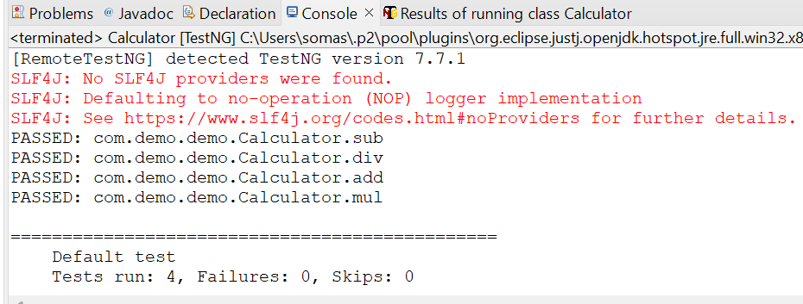

**TASK 3:**

package com.demo.demo;

import org.testng.annotations.Test;

import io.github.bonigarcia.wdm.WebDriverManager;

import org.testng.annotations.BeforeMethod;

import org.openqa.selenium.By;

import org.openqa.selenium.WebDriver;

import org.openqa.selenium.WebElement;

import org.openqa.selenium.chrome.ChromeDriver;

import org.openqa.selenium.chrome.ChromeOptions;

import org.testng.Assert;

import org.testng.annotations.AfterMethod;

public class Day7_03 {

WebDriver driver;

@Test

public void max_wid() {

WebElement from=driver.findElement(By.xpath("//*[@id=\"app\"]/div[1]/div/div[1]/div/div[2]/div[2]/form/div[1]/div/div[2]/input"));

from.sendKeys("Admin");

WebElement to=driver.findElement(By.xpath("//*[@id=\"app\"]/div[1]/div/div[1]/div/div[2]/div[2]/form/div[2]/div/div[2]/input"));

to.sendKeys("admin123");

WebElement submitBtn=driver.findElement(By.xpath("//*[@id=\"app\"]/div[1]/div/div[1]/div/div[2]/div[2]/form/div[3]/button"));

submitBtn.click();

String CurrentUrl=driver.getCurrentUrl();

String ExpectedUrl="https://opensource-demo.orangehrmlive.com/web/index.php/dashboard/index";

Assert.assertEquals(CurrentUrl, ExpectedUrl);

}

@BeforeMethod

public void beforeMethod() throws InterruptedException {

WebDriverManager.chromedriver().setup();

ChromeOptions co=new ChromeOptions();

co.addArguments("--remote-allow-origins=*");

driver=new ChromeDriver(co);

driver.get("https://opensource-demo.orangehrmlive.com/web/index.php/auth/login");

driver.manage().window().maximize();

Thread.sleep(3000);

}

@AfterMethod

public void afterMethod() {

driver.close();

}

}

**OUTPUT;**

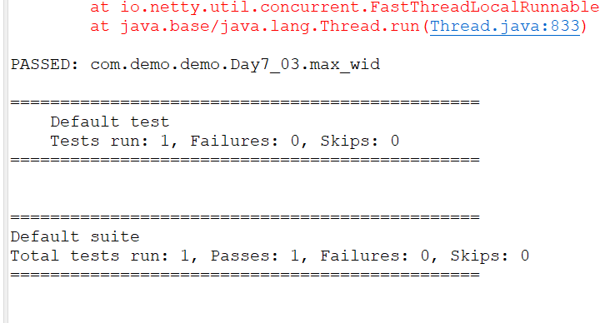

**TASK 4:**

**package** com.demo.demo;

**import** org.openqa.selenium.By;

**import** org.openqa.selenium.WebDriver;

**import** org.openqa.selenium.chrome.ChromeDriver;

**import** org.openqa.selenium.chrome.ChromeOptions;

**import** org.testng.Assert;

**import** org.testng.annotations.Test;

**import** io.github.bonigarcia.wdm.WebDriverManager;

**public** **class** Day7_04{

WebDriver driver;

@Test(priority=1)

**public** **void** Login() **throws** InterruptedException {

ChromeOptions co=**new** ChromeOptions();

co.addArguments("--remote-allow-origins=*");

WebDriverManager.*chromedriver*().setup();

driver=**new** ChromeDriver(co);

driver.get("https://opensource-demo.orangehrmlive.com/web/index.php/auth/login");

driver.manage().window().maximize();

Thread.*sleep*(3000);

driver.findElement(By.*xpath*("//input[@name='username']")).sendKeys("Admin");

driver.findElement(By.*xpath*("//input[@name='password']")).sendKeys("admin123");

driver.findElement(By.*xpath*("//*[@id=\"app\"]/div[1]/div/div[1]/div/div[2]/div[2]/form/div[3]/button")).click();

Assert.*assertEquals*(driver.getCurrentUrl(),"https://opensource-demo.orangehrmlive.com/web/index.php/dashboard/index");

}

@Test(priority=2, dependsOnMethods=("Login"))

**public** **void** Logout() **throws** InterruptedException {

Thread.*sleep*(3000);

driver.findElement(By.*xpath*("//span[@class=\"oxd-userdropdown-tab\"]")).click();

Thread.*sleep*(3000);

driver.findElement(By.*xpath*("//ul[@class=\"oxd-dropdown-menu\"]/li[4]/a")).click();

Assert.*assertEquals*(driver.getCurrentUrl(),"https://opensource-demo.orangehrmlive.com/web/index.php/auth/login");

}

}

**OUTPUT:**

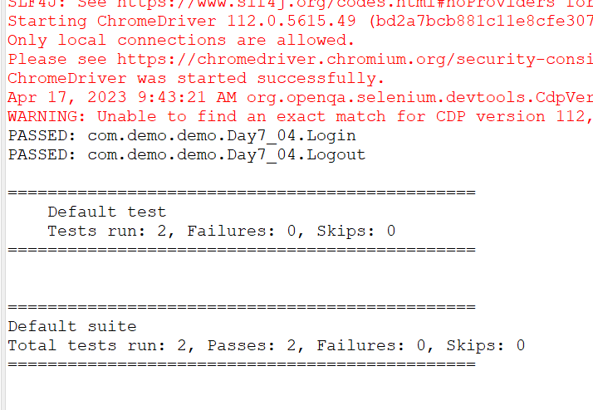

**TASK 5:**

**package** com.demo.demo;

**import** org.testng.annotations.Test;

**import** io.github.bonigarcia.wdm.WebDriverManager;

**import** org.testng.annotations.BeforeMethod;

**import** java.util.concurrent.TimeUnit;

**import** org.openqa.selenium.By;

**import** org.openqa.selenium.WebDriver;

**import** org.openqa.selenium.chrome.ChromeDriver;

**import** org.openqa.selenium.chrome.ChromeOptions;

**import** org.testng.Assert;

**import** org.testng.annotations.AfterMethod;

**public** **class** Day7_05

{

WebDriver d;

@Test(groups=&quot;Smoke Test&quot;)

**public** **void** t1()

{

String eurl=&quot;https://www.godaddy.com/en-in&quot;;

String curl=d.getCurrentUrl();

Assert.assertEquals(eurl,curl);

String etitle=&quot;Domain Names, Websites, Hosting &amp; Online Marketing Tools - GoDaddy IN&quot;;

String ctitle=d.getTitle();

Assert.assertEquals(etitle,ctitle);

}

@Test(groups=&quot;Regression Test&quot;)

**public** **void** t2()

{

d.manage().timeouts().implicitlyWait(10,TimeUnit.SECONDS);

d.findElement(By.xpath(&quot;//*[@id=\&quot;id-631b049a-e9c0-4d24-8710-

c504745206dd\&quot;]/div[2]/div[1]/ul/li[1]/button&quot;)).click();

d.findElement(By.xpath(&quot;//*[@id=\&quot;id-631b049a-e9c0-4d24-8710-

c504745206dd\&quot;]/div[2]/div[1]/ul/li[1]/div/div[2]/div[1]/ul/li[2]/a&quot;)).click();

}

@Test(groups=&quot;Regression Test&quot;)

**public** **void** t3()

{

d.manage().timeouts().implicitlyWait(10,TimeUnit.SECONDS);

d.findElement(By.xpath(&quot;//*[@id=\&quot;id-631b049a-e9c0-4d24-8710-

c504745206dd\&quot;]/div[2]/div[1]/ul/li[1]/button&quot;)).click();

d.findElement(By.xpath(&quot;//*[@id=\&quot;id-631b049a-e9c0-4d24-8710-

c504745206dd\&quot;]/div[2]/div[1]/ul/li[1]/div/div[2]/div[1]/ul/li[2]/a&quot;)).click();

String ctitle=d.getTitle();

String etitle=&quot;GoDaddy Domain Search - Buy and Register Available Domain Names&quot;;

System.out.println(ctitle);

Assert.assertEquals(etitle, ctitle);

}

@BeforeMethod

**public** **void** beforeMethod()

{

ChromeOptions co=**new** ChromeOptions();

co.addArguments(&quot;--remote-allow-origins=*&quot;);

WebDriverManager.chromedriver().setup();

d=**new** ChromeDriver(co);

d.get(&quot;https://www.godaddy.com/en-in&quot);

d.manage().window().maximize();

}

@AfterMethod

**public** **void** afterMethod()

{

d.close();

}

}

**OUTPUT:**

